How to Make Old-Fashioned Cupcake

Cupcakes are a delicious and rich dessert, and they're perfect for almost any occasion.

Whether you want to host a fun party, celebrate a birthday or another special occasion, or if you just want to enjoy a delicious treat for the fun of it, then cupcakes are the food for you.

**Prep time (Old-Fashioned):** 20-25 minutes

**Cook time:** 17-20 minutes

**Total time:** 35-45 minutes

**Ingredients list:**

1 3/4 flour (not self-rising)

1 1/4 cups unbleached all-purpose flour

2 cups sugar

1 tbsp. baking powder

3/4 tsp. salt

4 sticks unsalted cubed butter

4 large eggs

1 cup whole milk

1 tsp. pure vanilla extract

6 cups confectioners' sugar

1/2 cup milk.

2 tsp. vanilla extract

**Baking Old Fashioned Cupcakes**

**Step 1: Preheat** your oven to 325⁰ F (162⁰ C).

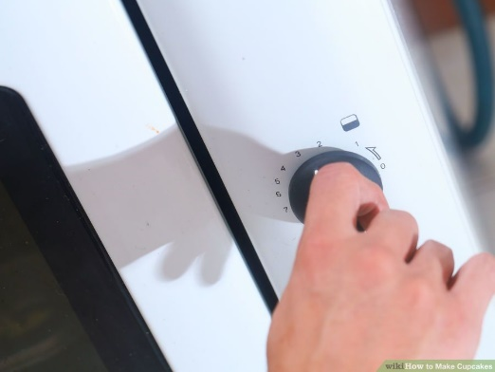

**Step 2: Line a cupcake pan with paper liners**. Set the pan aside.

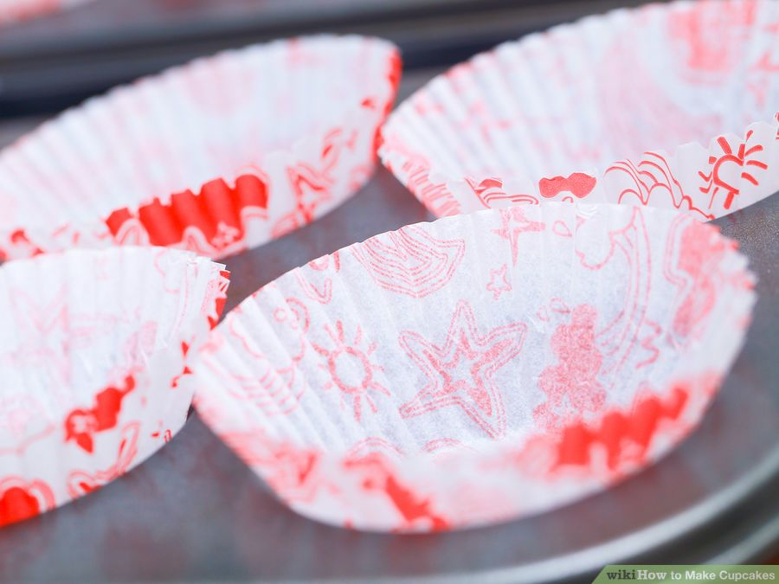

**Step 3: Combine the flour, sugar, baking powder, and salt in a bowl**. Combine 1 3/4 cups of cake flour (not self-rising), 1 1/4 cups of unbleached all-purpose flour, 2 cups of sugar, and 1 tsp. of baking powder together in a bowl. Mix the ingredients until they're combined, for about 3 minutes.

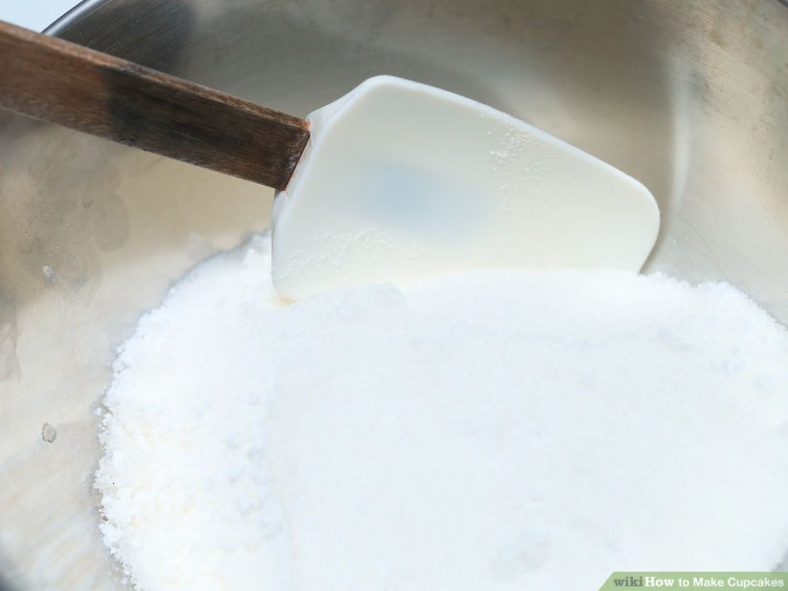

**Step 4: Add 4 sticks of unsalted cubed butter to the mixture.** Mix it in until the butter is just coated with flour.

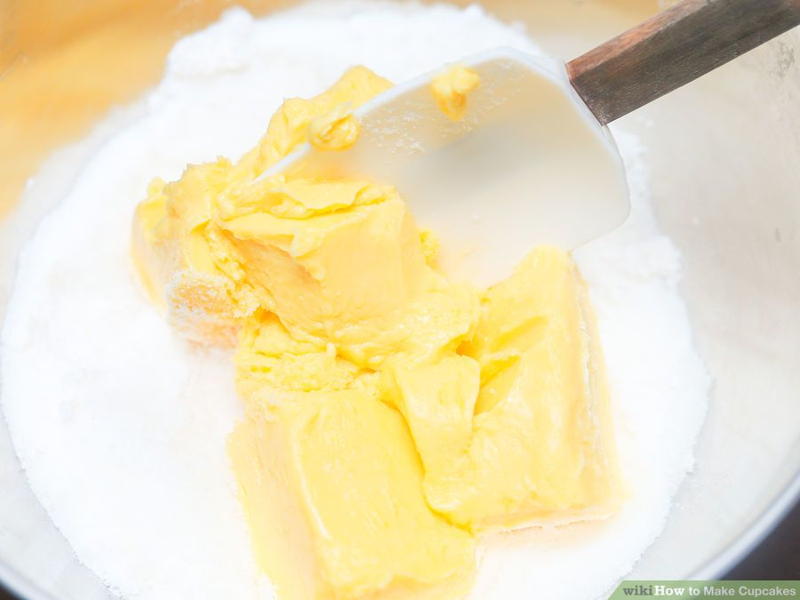

**Step 5: Add 4 large eggs to the mixture, one at a time.** Add the eggs one by one until each egg is incorporated into the mixture.

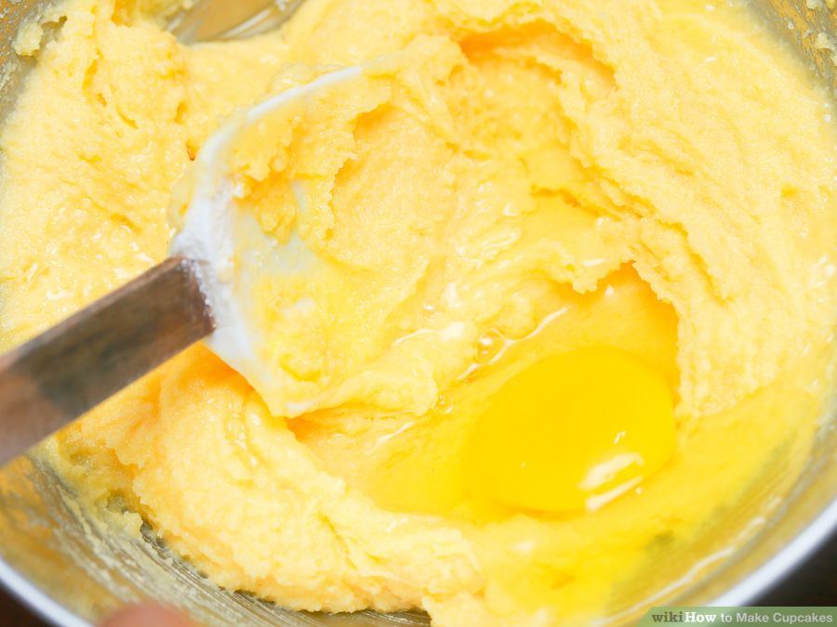

**Step 6: Add 1 cup of whole milk and 1 tsp. of pure vanilla extract to the batter.** Mix the ingredients together until they're completely mixed, taking the time to scrape down the bowl so no ingredients are stuck.

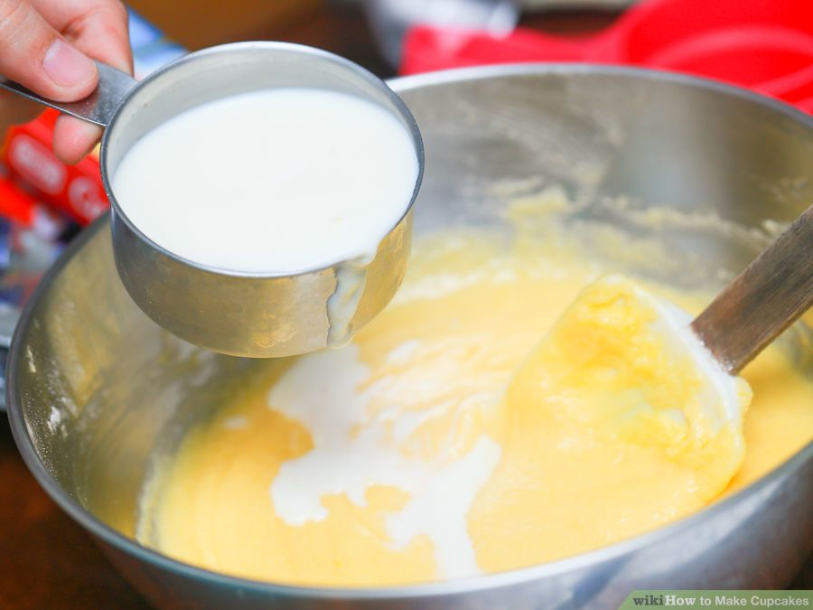

**Step 7: Fill each baking cup 2/3 full with the batter.** This will give the cupcakes enough room to expand.

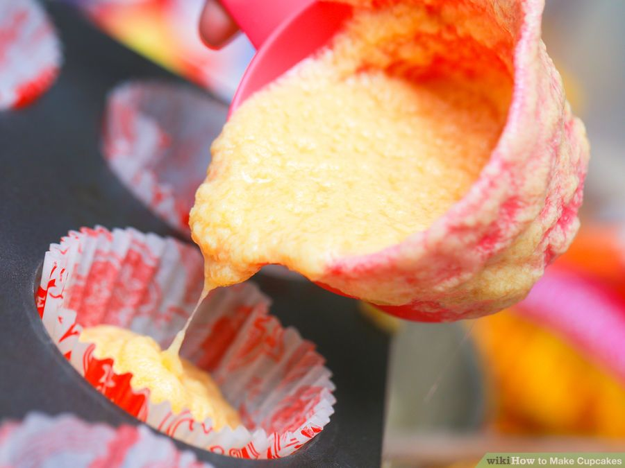

**Step 8: Bake for 17-20 minutes.** After 15 minutes, start inserting a toothpick into the cupcakes. Once it comes out clean, the cupcakes are done and should be taken out of the oven. Check back every 2 minutes until they're ready.

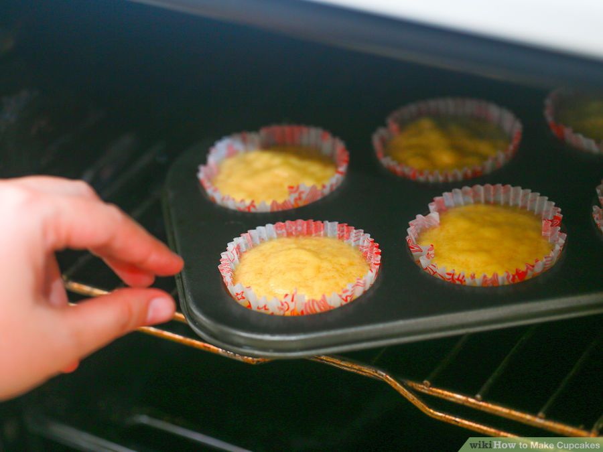

**Step 9: Make the frosting.** You can do this while the cupcakes are cooking. To make the frosting, just cream 2 sticks of softened butter, 3 cups of confectioners' sugar, 1/2 cup of milk, and 2 tsp. of vanilla extract together. Beat the mixture with a paddle until it is smooth and gradually add the other 3 cups of sugar until it is rich and creamy.

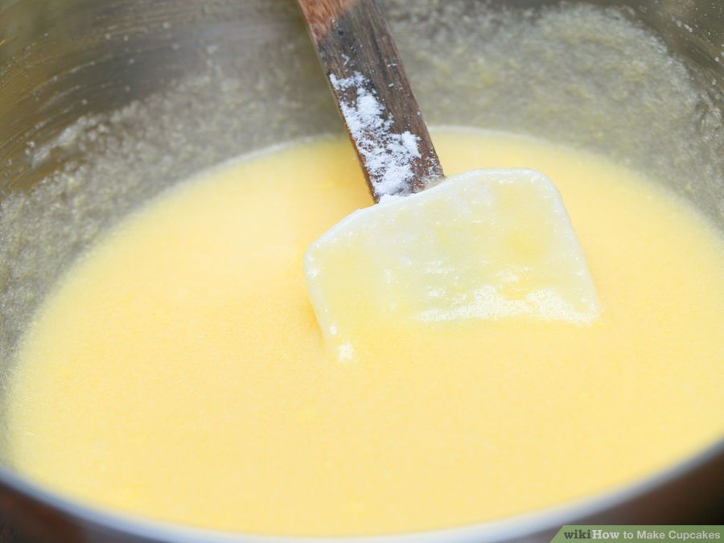

**Step 10: Cool the cupcakes.** Cool them for at least 3-5 minutes so they don't melt the frosting.

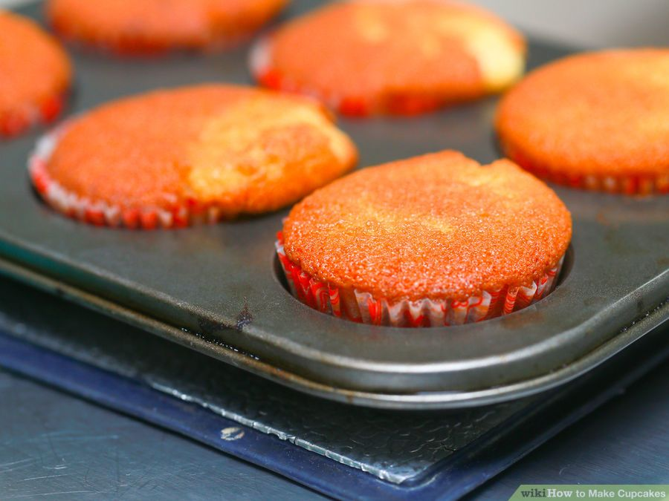

**Step 11: Decorate the cupcakes with the frosting.** Use a spoon or paddle to place the frosting generously over the tops of the cupcakes.

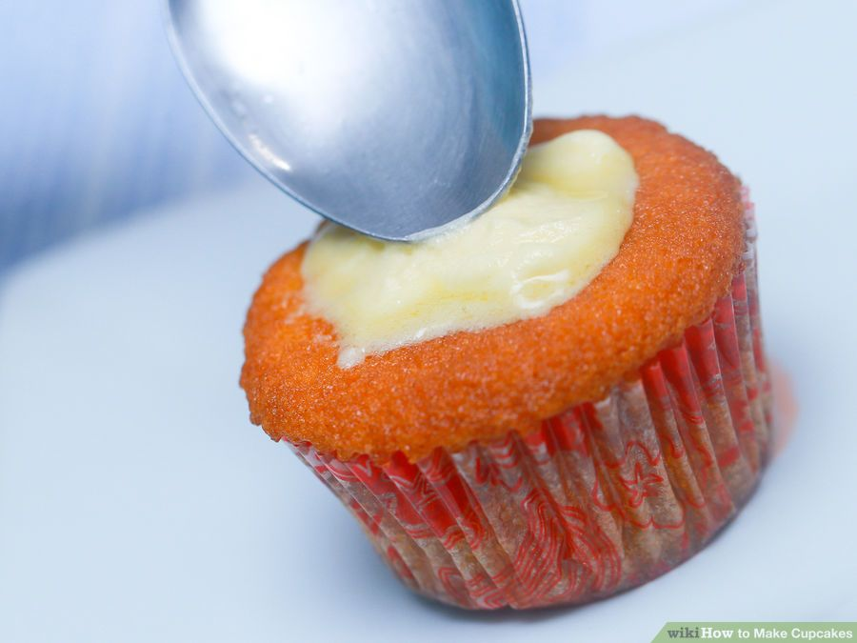

**Step 12: Enjoy** these tasty cupcakes any time at room temperature.

